3.4  
  
Task #1  
  
Prompt:  
  
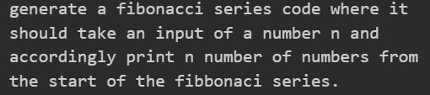  
  
Code :   
  
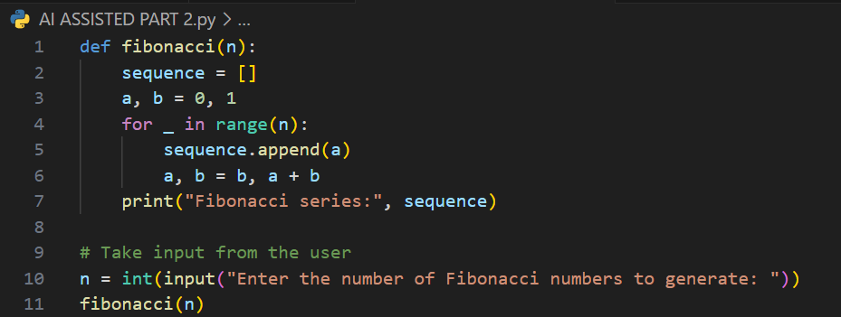  
  
  
Output:  
  
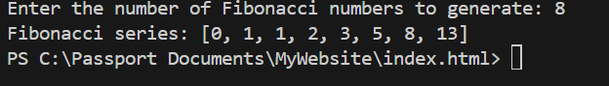

Task #2  
  
Prompt:  
  
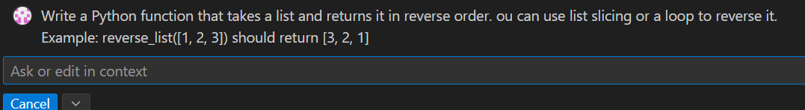  
  
Code:  
  
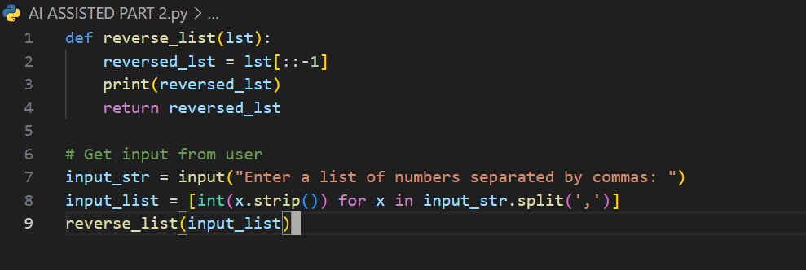  
  
Output:  
  
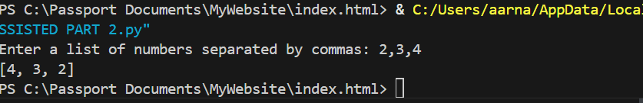

Task # 3  
  
Prompt:  
  
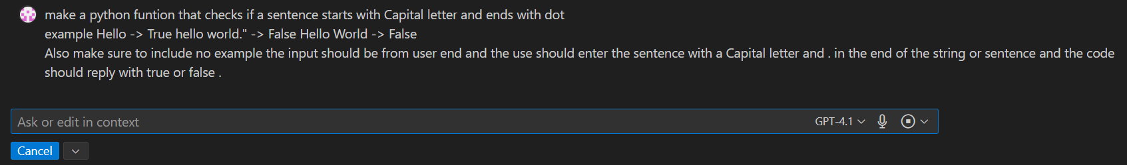  
  
Code:  
  
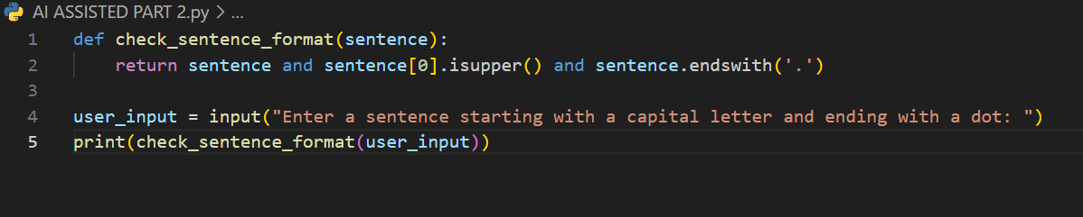  
  
Output:  
  
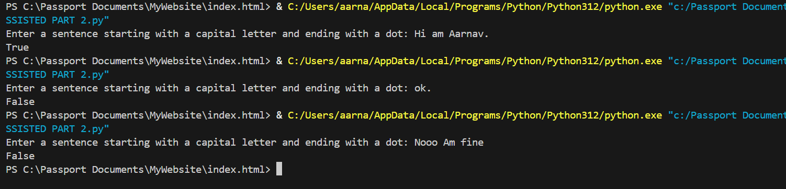  
  
  
  
  
  
  
  
  
  
  
  
Task #4  
  
Prompt zero shot:  
  
  
  
Prompt few shot:  
  
  
  
Code zero shot:  
  
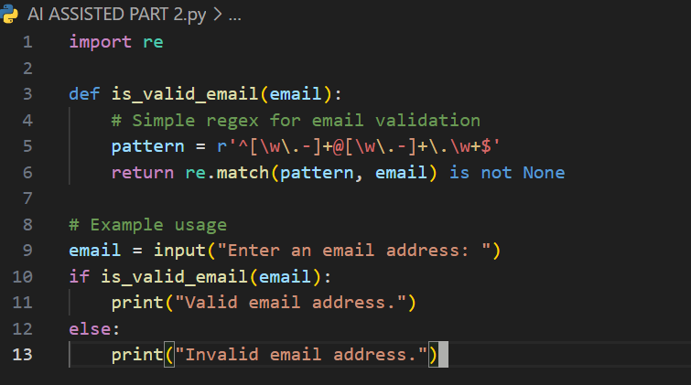

Code few shot:  
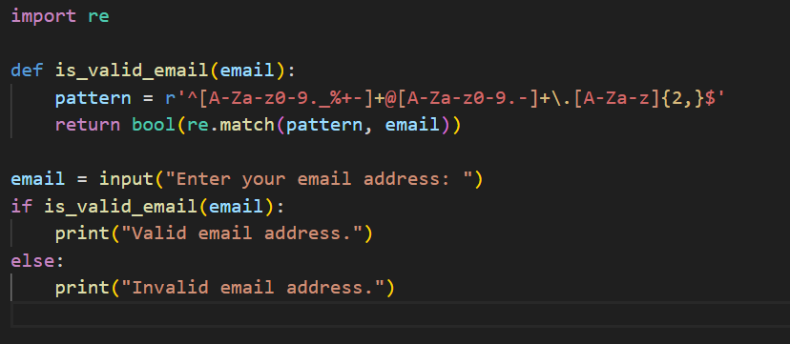  
  
Output zero shot:  
  
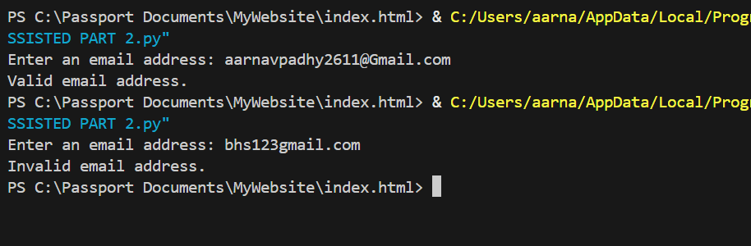  
  
Output few shot:  
  
  
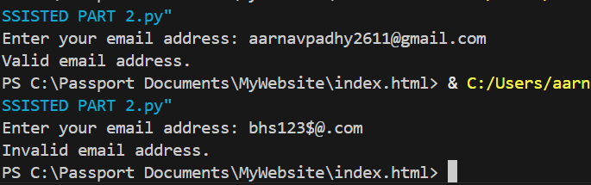  
Task 5  
  
Prompt a :  
  
  
  
Code a:  
  
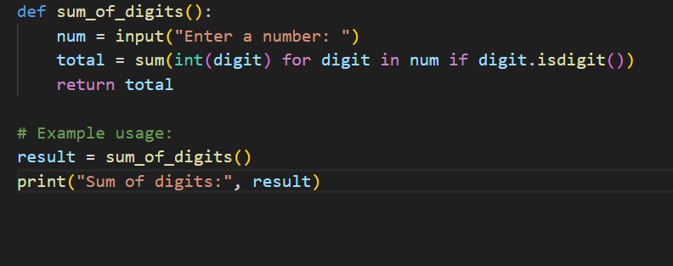  
  
  
Output a:  
  
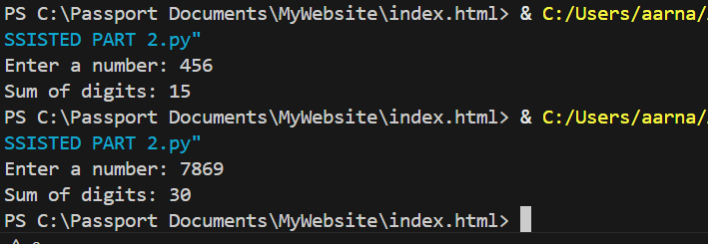  
  
  
  
Prompt b:  
  
  
  
Code b:  
  
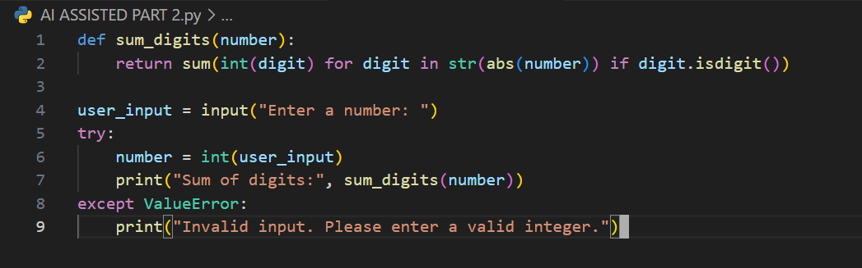  
  
Output b:  
  
